APS130 Photoshop Colourising old BW Photos
You can play with some old family photos or use old photos from the Internet.
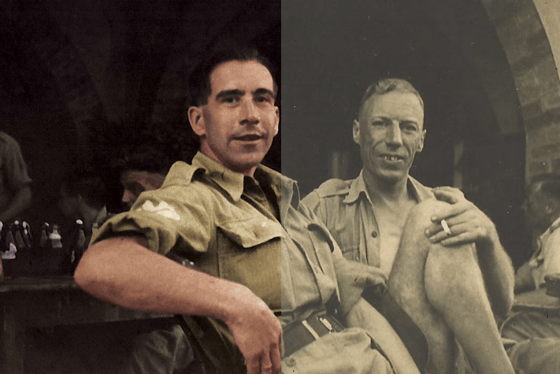
https://www.diyphotography.net/learn-colorize-black-white-photos-4-minutes/
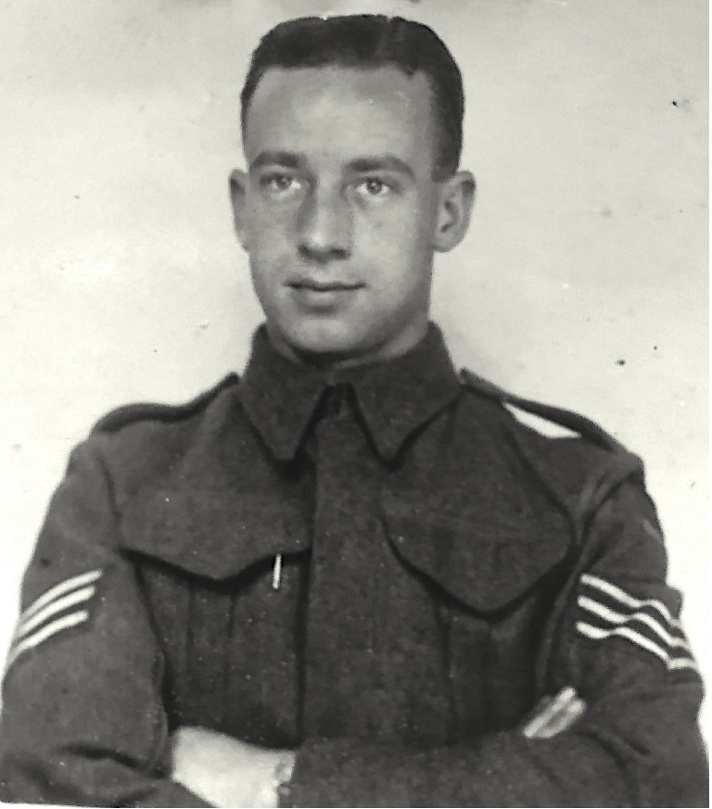

Copy an image or get one of your own

Open in Photoshop

Cleaning up the image
When you open the image in Photoshop, Show Layers (Window - Layers) Right click on the image thumbnail and convert it to Smart Object
Next start by removing the scratches and dust. You can go to Filter > Noise > Dust & scratches, and set the radius to 1-2 pixels and threshold to 20-30 levels.
If there are still some scratches and specks of dust left, you can clone them out manually.
From Filter go to Dust & Scratches
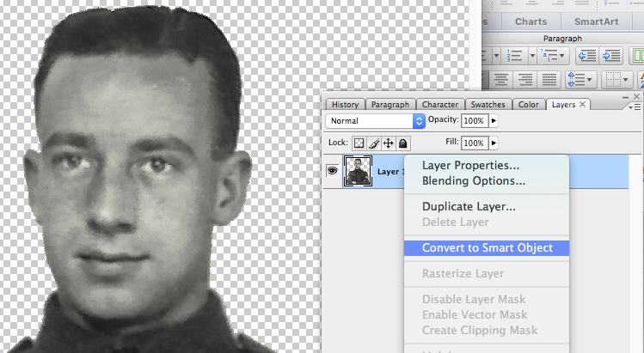
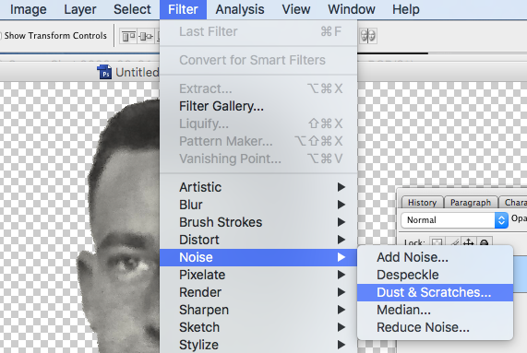

A value of 1 - 2 pixels should work and a threshold of 30 - 40 will be about right
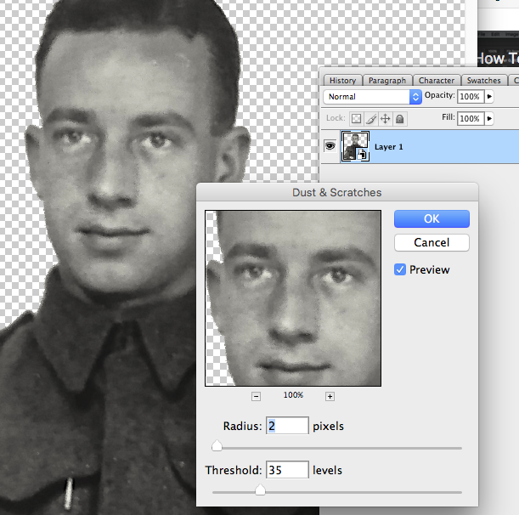

Adjust the image tones and contrast

If you’re working with a sepia image, add a Black & White adjustment layer to neutralize the tones. Then add Layers
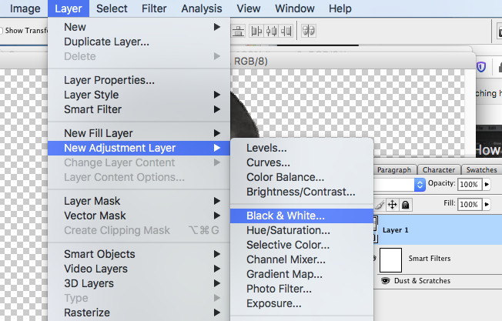
Add a Black & White adjustment layer

New Adjustment Levels adjustment layer to fix the contrast, and keep in mind you’ll probably need to darken the shadows quite a lot.
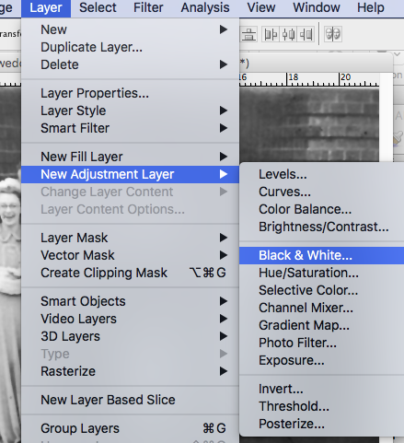
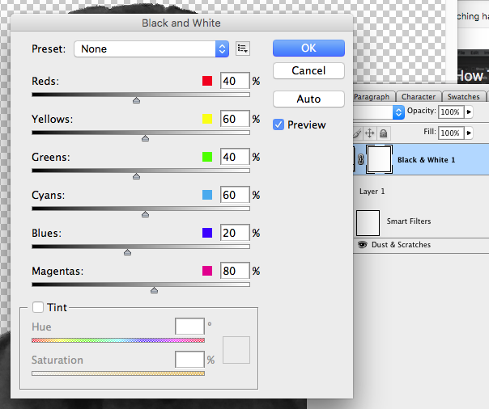

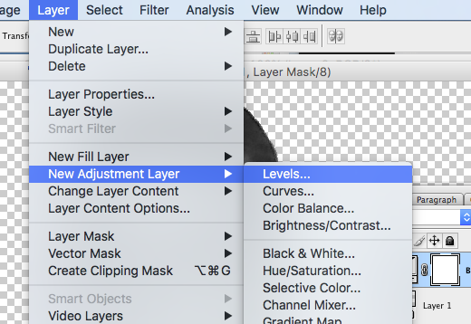
Adjustment Layer levels
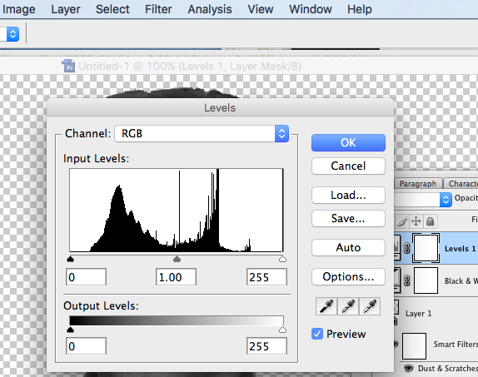
Darken Shadows
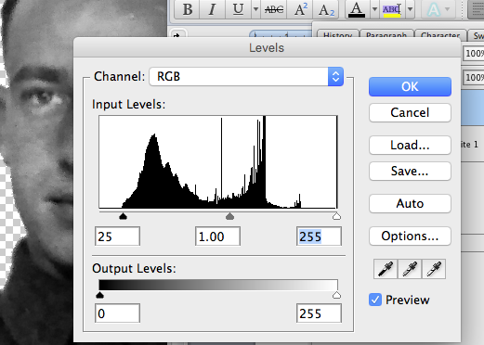
And a levels adjustment and close up the contrast to darken the shadows

Converting the image to CMYK
When you’re satisfied with the image, convert it to CMYK (Image > Mode > CMYK Color). This makes the original tones of the image show less if the photo is sepia, and colorizes the darker areas much better.
Convert the image to CMYK Image and when it asks to flatten or merge and click OK
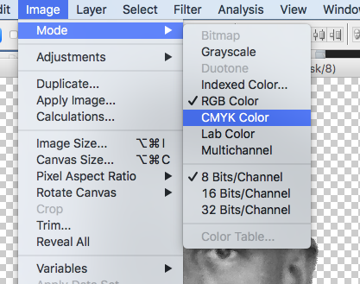

Do NOT Rasterise and then Merge
All your layers will merge into one

We now start colouring
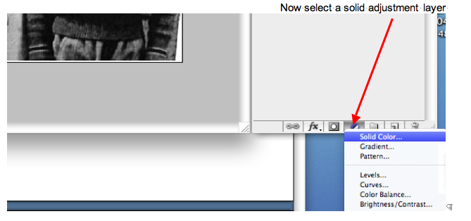
Pick a colour close to a skin shade
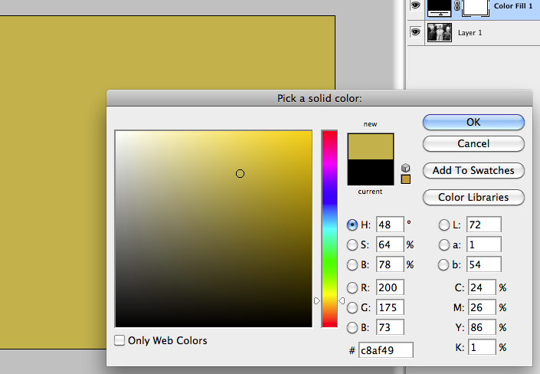
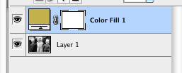
Click on the colour part of the smart object
and select Blending Options from the drop down memu
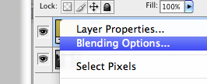

Select Soft light
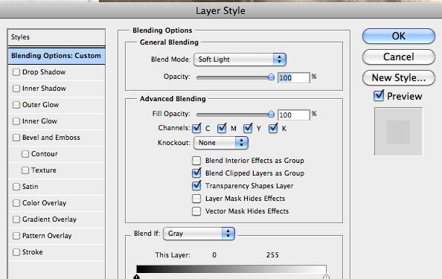

Set the blending mode to Soft Light, and you’ll notice your entire photo is toned with this color. Alternatively, you can choose a blending mode that will add more vibrancy to the selected hue and adjust the opacity if needed.

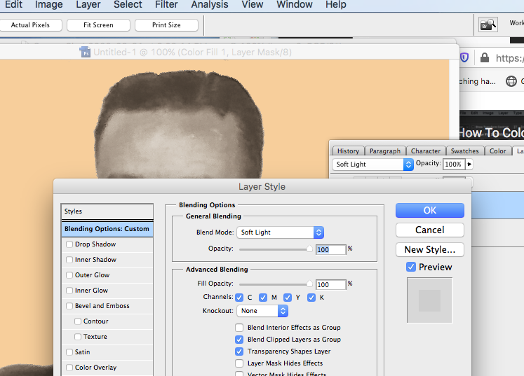

Pick Soft Light
Alternatively you could select Colour blending mode for stronger contrast
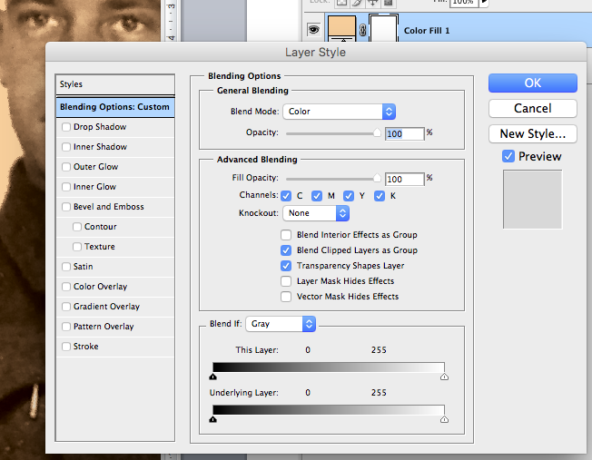

Select Layer Mask
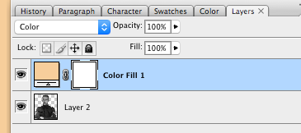
Fill it with Black
Next, select the layer mask next to the Solid Colour adjustment layer and fill it with black (Command + I) to clear the colour overlay.

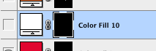

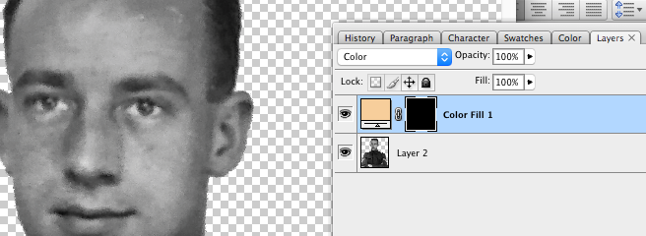

Adding colour
After the first three steps, your image is ready for colorization.
Make sure you select white as the foreground colour
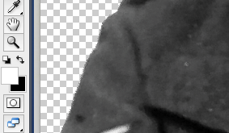
Start by adding a new Solid Color adjustment layer in the approximate hue of the area you’re working on. For example, choose the color of the skin.
You can move the colour to suit
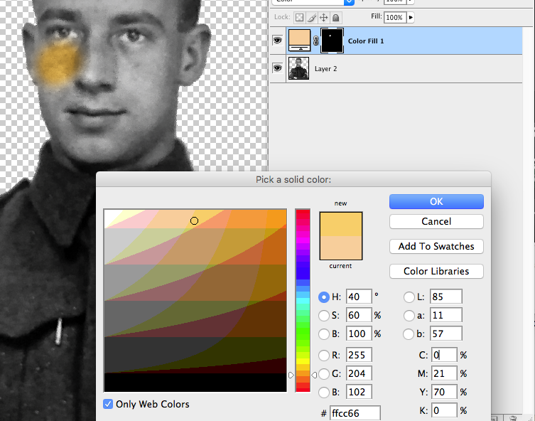

Now switch to the Brush Tool and adjust the hardness (10%) and size, depending on the area you’re working on. Choose the white color for the brush and start painting over the areas where you want the color to reveal. In this case, the skin.
Switch the brush to black to remove the color from unwanted areas or clear any mistakes.

From this point, you can change the color of the Solid Color adjustment layer, as it’s easier to manage the hue when you see it in the image. You can also adjust the opacity of the layer to tone it down, if necessary.

As you move the point around the colour will change.
When you’re done with the skin, apply the same principle to all the other areas: lips, clothes, background, jewelry and so on.
Keep in mind that adding some color in the specific areas makes the colorization look more realistic. For example, some pink around the eyes, blue around the chin, yellowish tones on the skin and so on. All these should be made practically invisible, with opacity under 20%, but they’ll add some nice color variation to the image.
When you add color to the photo, have in mind that a pen tablet makes the process much easier and more precise. But it’s still possible to do it with the mouse, and you can use a Pen Tool to make selections before applying color.
Once you’ve finished with adding color to all the areas, there are some final tweaks to improve the image further.

Add a Color/Saturation adjustment layer on top of the layer stack, to add some vibrancy to the image. You can also add a Color Balance adjustment layer to correct the overall tone of the image.
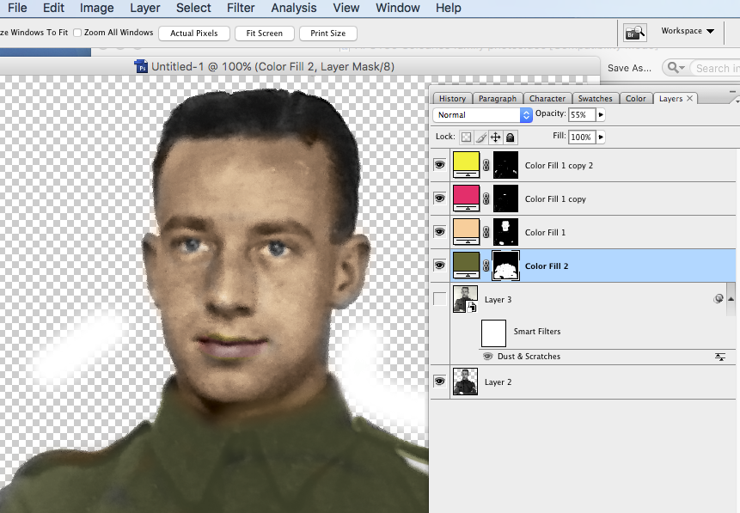

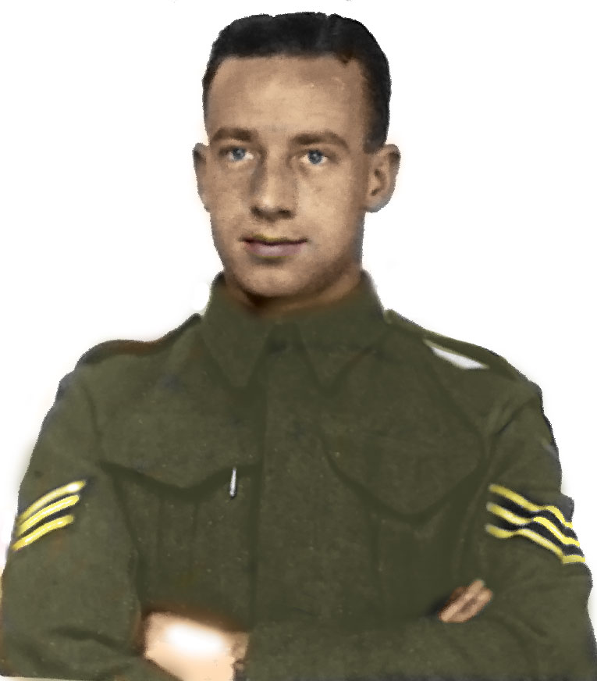

You could choose Colour for more vibrant colours but we will stick to soft light.

